5.78: a) Taking components along the direction of the plane’s descent, 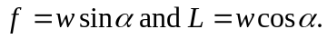 b) Dividing one of these relations by the other cancels the weight, so 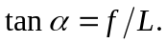 c) The distance will be the initial altitude divided by the tangent of . 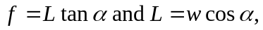 therefore 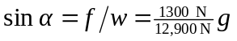 and so 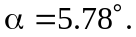 This makes the horizontal distance 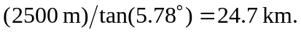 d) If the drag is reduced, the angle is reduced, and the plane goes further.

